8.2 DFD Level 2 – Registration and Authentication
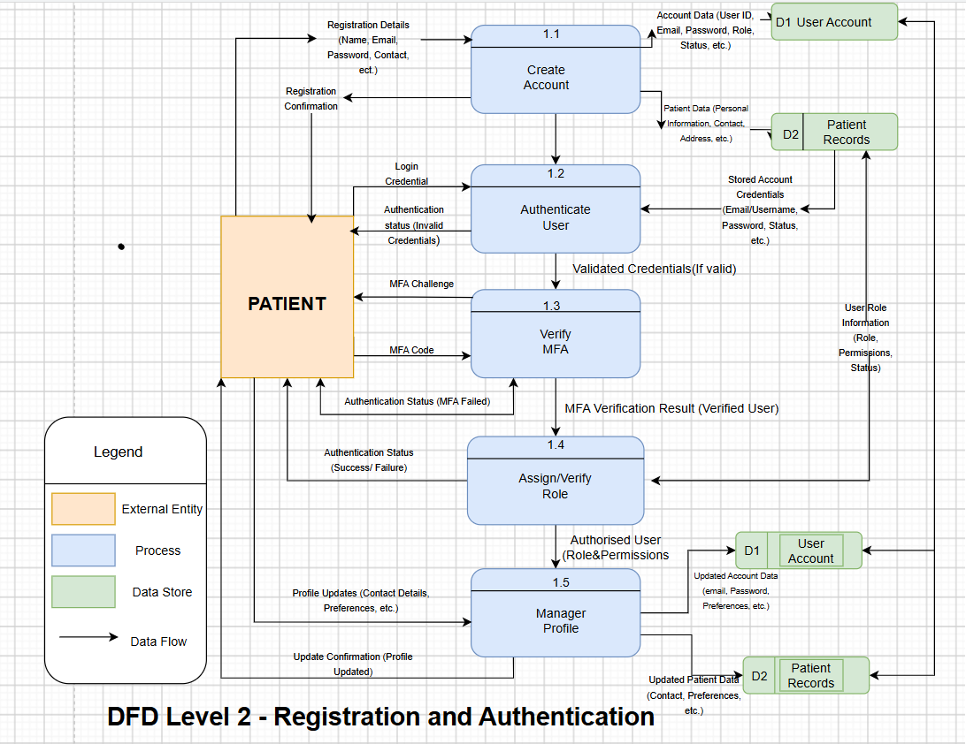
The Level 2 Data Flow Diagram (DFD) provides a detailed decomposition of the Registration and Authentication (1.0) process presented in the Level 1 DFD. Using the Gane and Sarson notation, the process is divided into five main subprocesses: 1.1 Create Account, 1.2 Authenticate User, 1.3 Verify MFA, 1.4 Assign/Verify Role, and 1.5 Manage Profile. These subprocesses illustrate how patient registration details, login credentials, authentication information, role information, and profile updates are processed within the system.
During account creation, the patient provides registration details, which are processed by 1.1 Create Account and stored in D1 User Account and D2 Patient Records. When logging in, 1.2 Authenticate User validates the patient's login credentials against the stored account information. Valid credentials are passed to 1.3 Verify MFA, where an additional authentication challenge is performed. After successful verification, 1.4 Assign/Verify Role determines the user's role and permissions and returns the authentication status. Finally, 1.5 Manage Profile allows an authorised user to update permitted profile information, with relevant changes stored in the user account and patient records. This decomposition supports secure authentication and role-based access control while maintaining the registration, authentication, and profile-management functions defined in the system requirements. The project requirements specifically include user registration, authentication, MFA, RBAC and user profile management.

